How to add JCalendar component to NetBeans IDE palette

[March 04, 2017](https://aziosworld.blogspot.com/2017/03/how-to-add-jcalendar-component-to.html)

How to add JCalendar component to NetBeans IDE palette  
  
  
Who wants to implement a datepicker module in your application developed with NetBeans IDE, JCalendar is a Java date chooser bean for graphically picking a date. JCalendar is composed of several other Java beans, a JDayChooser, a JMonthChooser and a JYearChooser. You will need to download the jcalendar-1.4.zip from here http://toedter.com/jcalendar/ . Jcalendar-1.4.zip file contains all sources, libs and documentation .After downloading “jcalendar-1.4.zip” file, extract it using zip file manager application like winrar or 7zip .Go to exaction location and you can see lot files in it. Locate and open folder named “lib” and you can see the file named jcalendar-1.4.jar. Place jar file in your folder.

[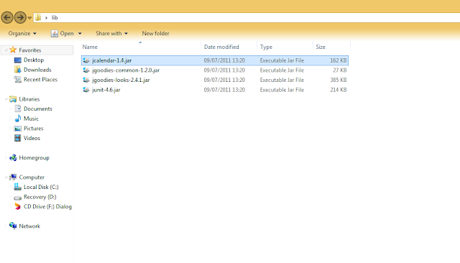](https://1.bp.blogspot.com/-5HXA0bA5T_Q/WP-VtscwcRI/AAAAAAAABuA/6wh1CYJXkiY0P3IzszxFX9QYKlUGzspDACLcB/s1600/1.PNG)

Next step is to include the JCalendar component in your NetBeans Palette. Default NetBeans IDE palette looks following screen shot.

[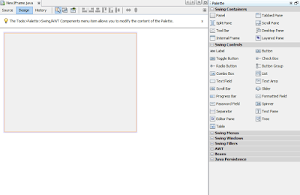](https://3.bp.blogspot.com/-sQdQ_fTUic8/WP-Vvh2f-wI/AAAAAAAABuY/hYm6RYtvAtEkjKEIJt0bAjP7_3ffv-hZwCEw/s1600/4.PNG)

From Tools menu select Palette > Swing/AWT Components or Right Click on palette and choose Palette Manger. This will open Palette Manger Window that provides a way to organize components in NetBeans palette.

[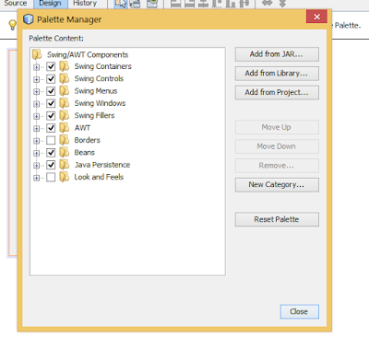](https://3.bp.blogspot.com/-OXSyBwwJ55M/WP-VwWRnS4I/AAAAAAAABug/hSxbrIWG_lA4dr9rbM-T3zoI4MXm0mj_QCEw/s1600/6.PNG)

 I suggest to create a new category for your extra components. So click on New Category button in palette manager and create new palette category.

[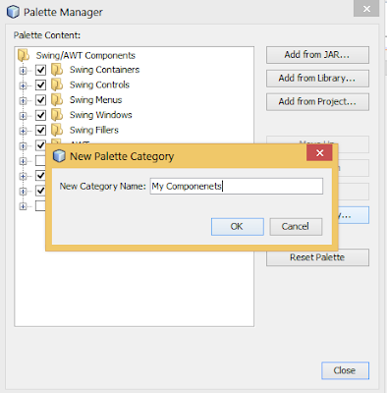](https://1.bp.blogspot.com/-JfJqE9SDTJk/WP-VwMnQKmI/AAAAAAAABuw/AcfhMn9nMJgjD2LBaZdIiGi6dRpT3DFJQCEw/s1600/5.PNG)

Now click on Add from JAR button and browse to jcalendar-1.4.jar file location. Clicking Next button the dialog box shows containing components of JCalenndar to choose from, that can be add to the palette.

[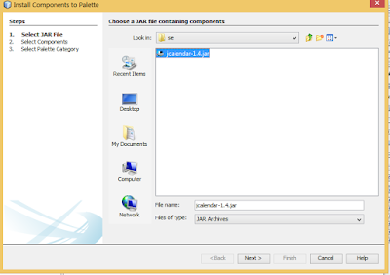](https://4.bp.blogspot.com/-3BNCGeb7Hds/WP-Vwk8lGFI/AAAAAAAABuw/inmRpdJoKhkYO8M2fYROjf_MBcVl-NaeACEw/s1600/7.PNG)

Following dialog is a multi-selection dialog, so you can choose any component you need. Select what you need.

[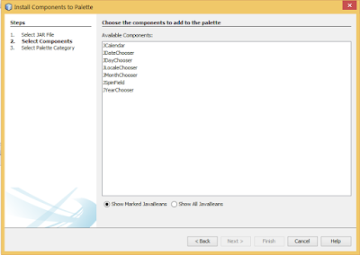](https://4.bp.blogspot.com/-Ory-RVIXoCU/WP-Vw_omYbI/AAAAAAAABuw/Y2sTFjOAvHQ0qWPkS83QrDaASNmHmsI4gCEw/s1600/8.PNG)

On clicking Next again you will be able to categorize the newly imported components. Select comfort category and press Finish button. After clicking Finish button close the palette manager window.

[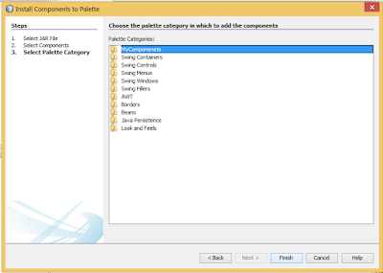](https://4.bp.blogspot.com/-9NJ_EM73gps/WP-VxFUEZhI/AAAAAAAABuw/AuO2l5U3a8Ia9EYpqo02iswfRYL3ArzEACEw/s1600/9.PNG)

Now we have JCalendar Component pack in NetBeans palette.

[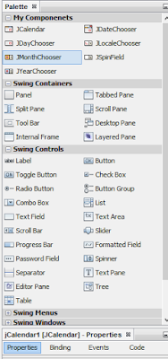](https://4.bp.blogspot.com/-zbePw1IpKlk/WP-VtiOo6pI/AAAAAAAABuw/rf11m_OXEG8rbjN9JzVIuv0n4gNVN2grACEw/s1600/10.PNG)

You can easily drag and drop any of this Component to your workspace and use it. When you compile and build the code you will your application jar file along with a lib folder that contains supporting JCalendar file without which the application will not run.

[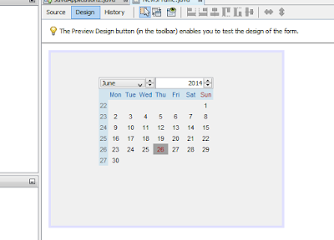](https://1.bp.blogspot.com/--YVd4-FhVY0/WP-VuTViE8I/AAAAAAAABuw/GpKWJdhBKrAF5eOBAFsiYPXeJpLQusAcwCEw/s1600/13.PNG)

[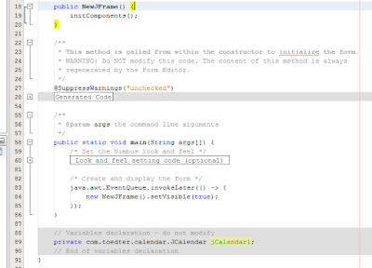](https://2.bp.blogspot.com/-Dfv4cijo2fM/WP-VuFmNawI/AAAAAAAABuw/CP4K2t9-mAskOAVZ7XkNX1oz0rlL7CKRACEw/s1600/12.PNG)